**Steps To Backup and Restore Database**

**In DB Server**

**Step – 1 – Backup the Database file in local Directory**

1. Open SSMS and connect to the server **“3.142.159.237”**

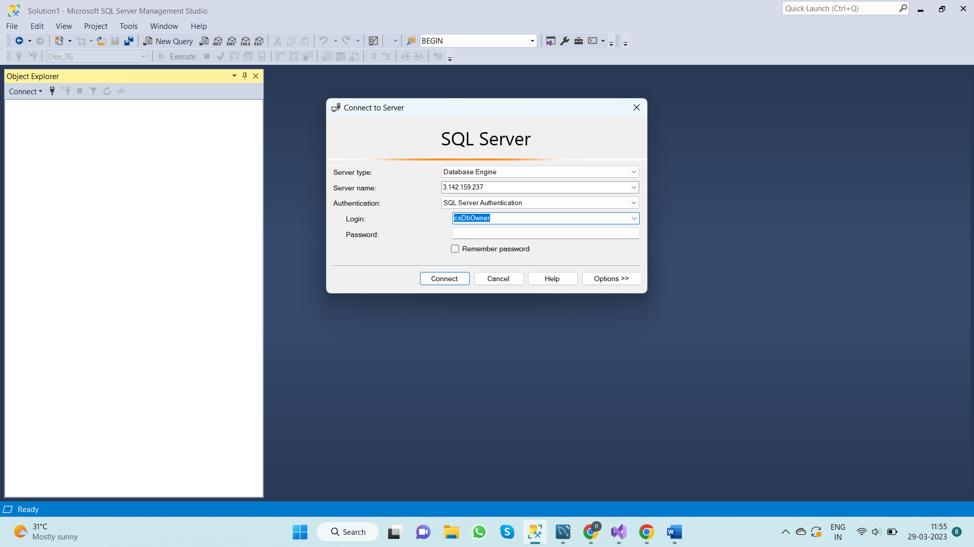

1. Expand Databases tab to find the Database **“Dev_TG”**

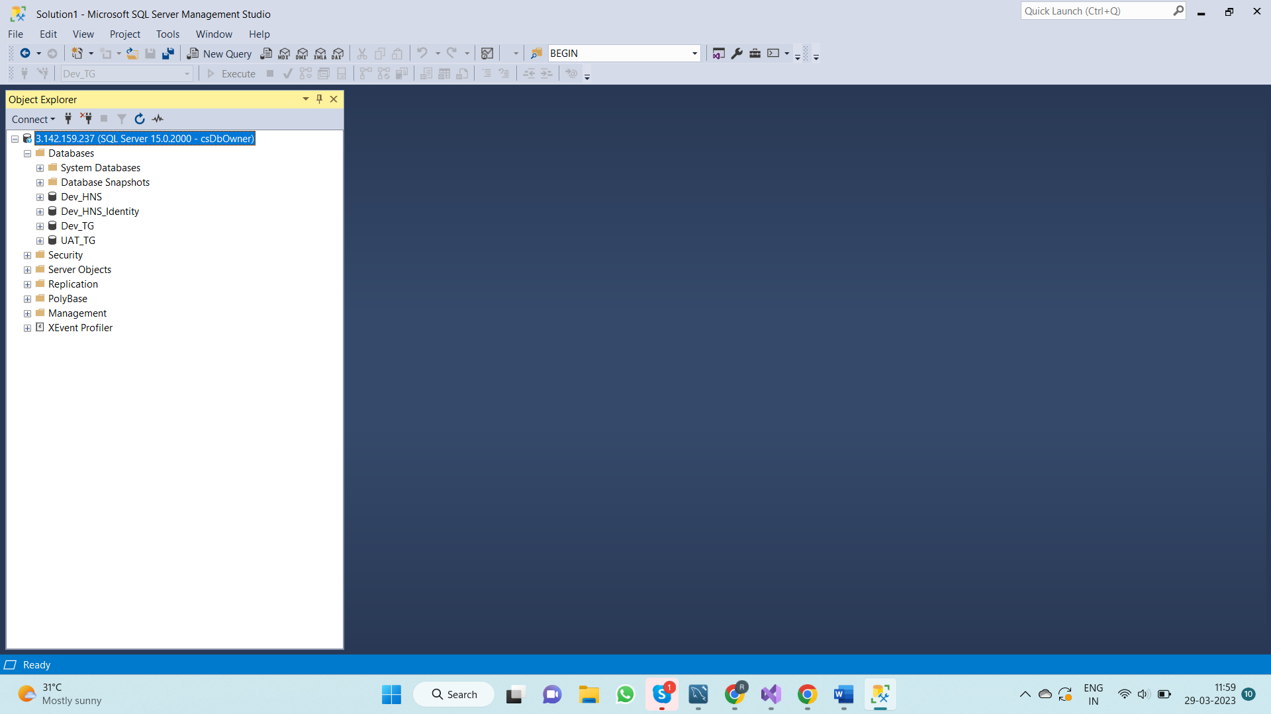

1. Right click on **“Dev_TG”** select **“Tasks”** and then select **“Back Up…”**

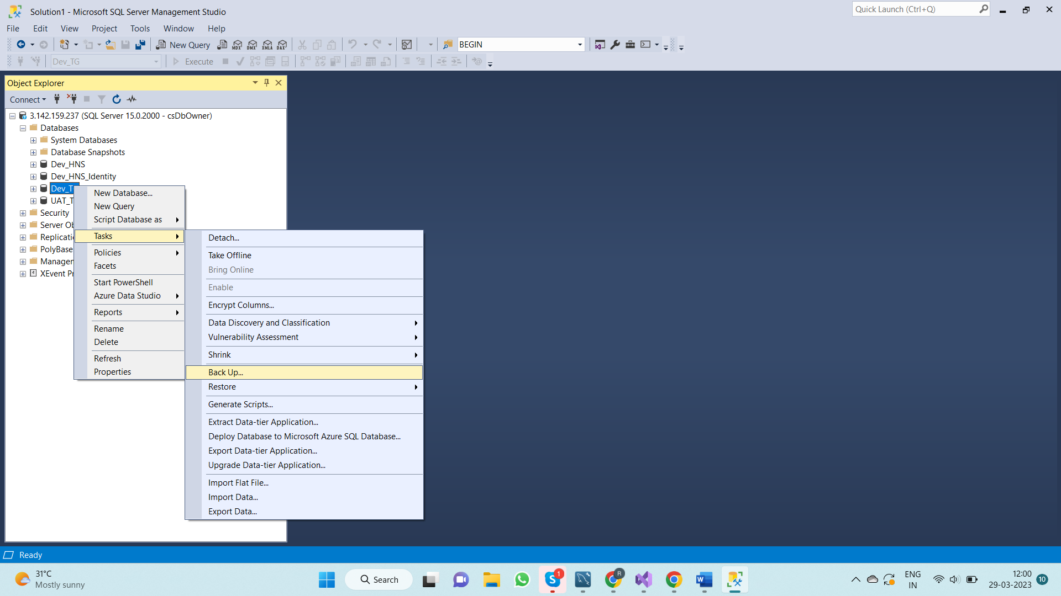

1. Select Database as **“Dev_TG”** and **“Backup Type”** as full.

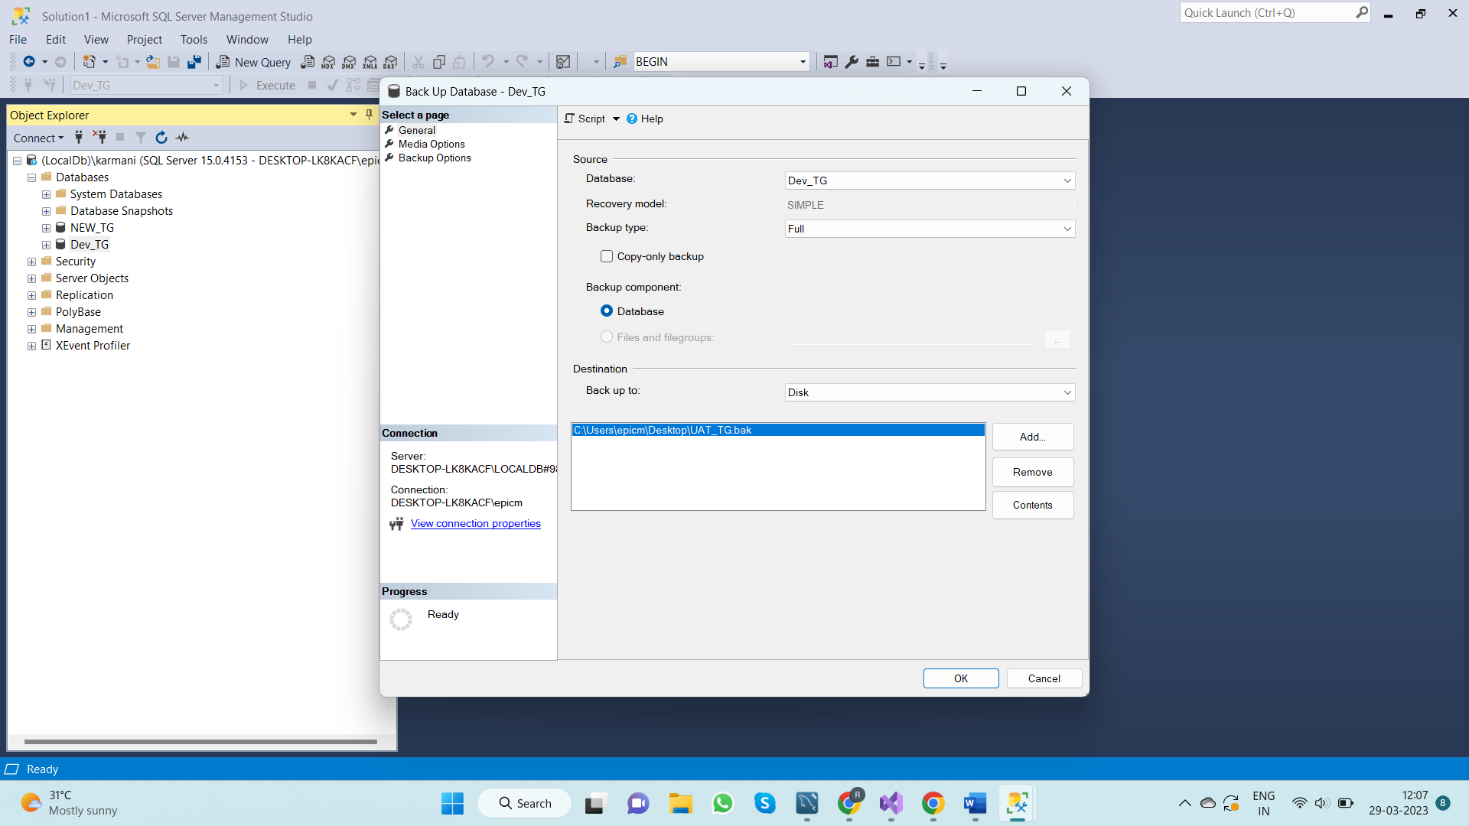

1. Click on **“add”** and Browse for the new path to back up the file and givethe file name as **“Dev_TG_20230329.bak” (suffix it with current date) and “Click ok”**

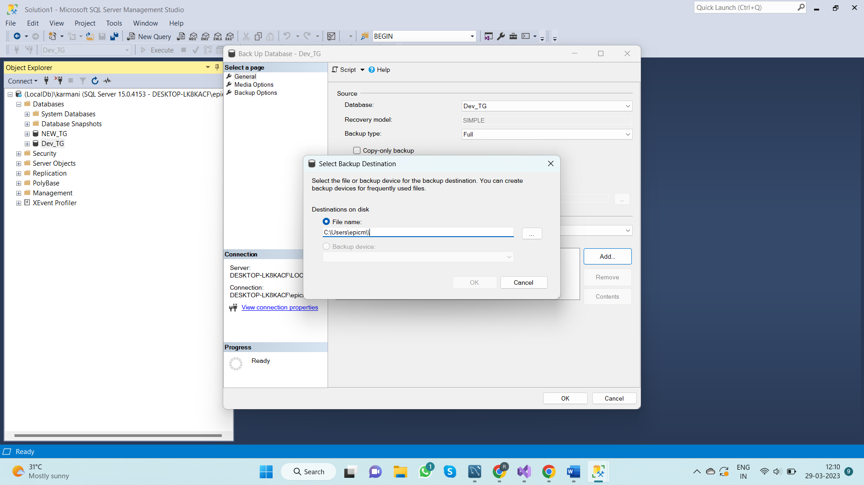

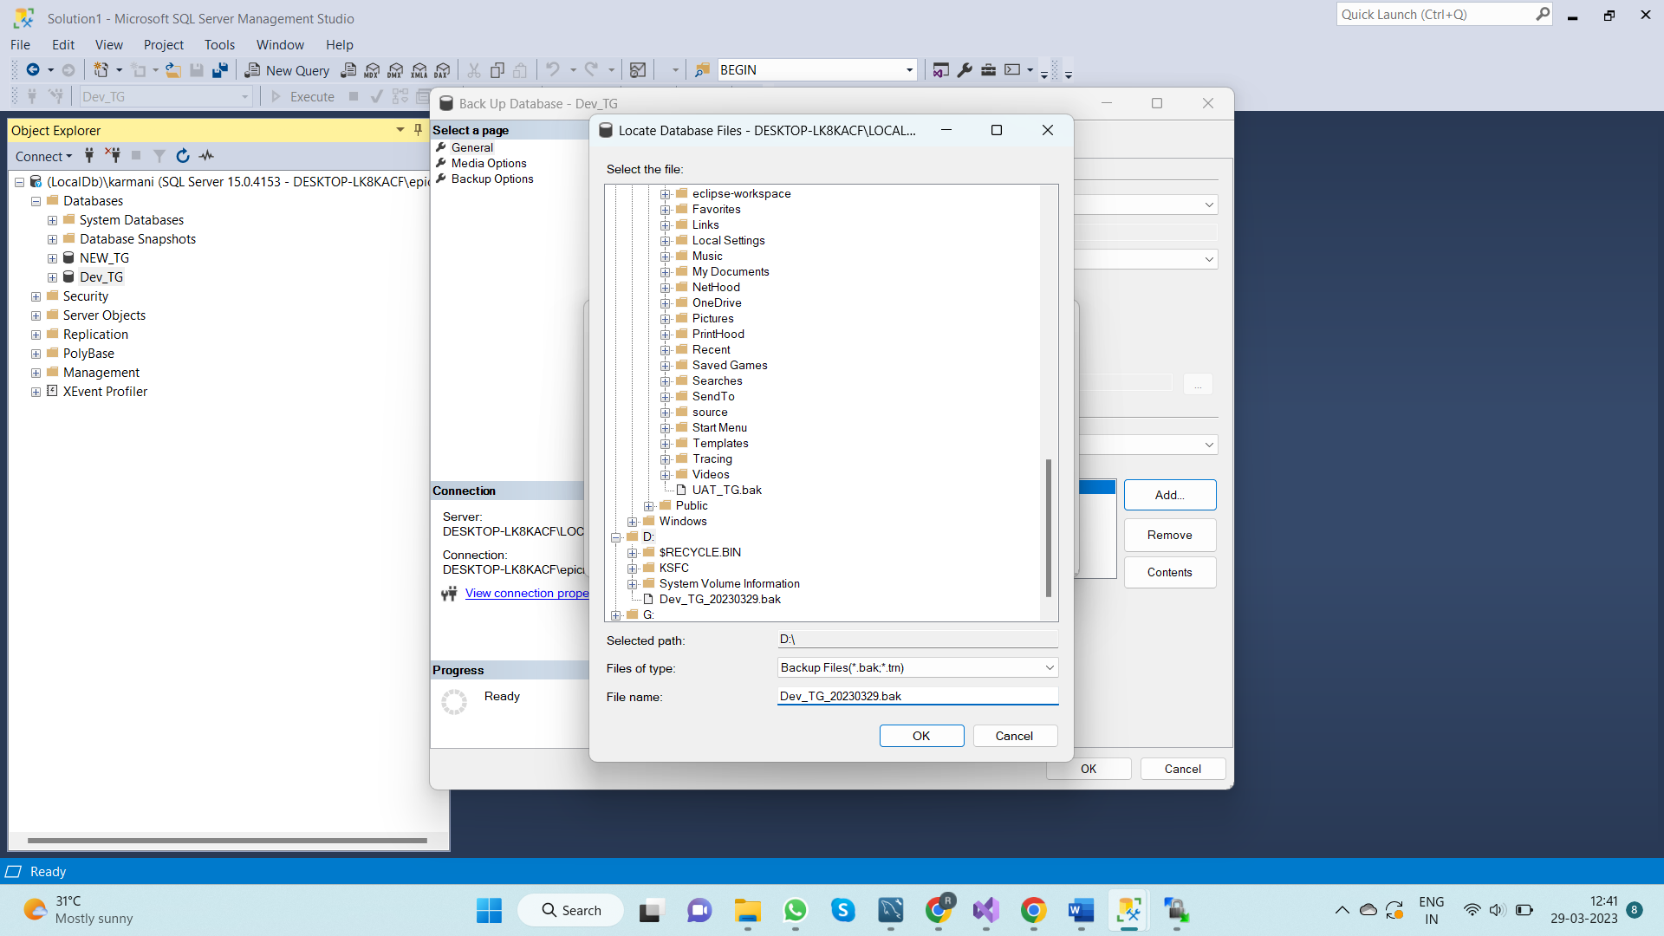

1. Select the new path and click **“Ok”**

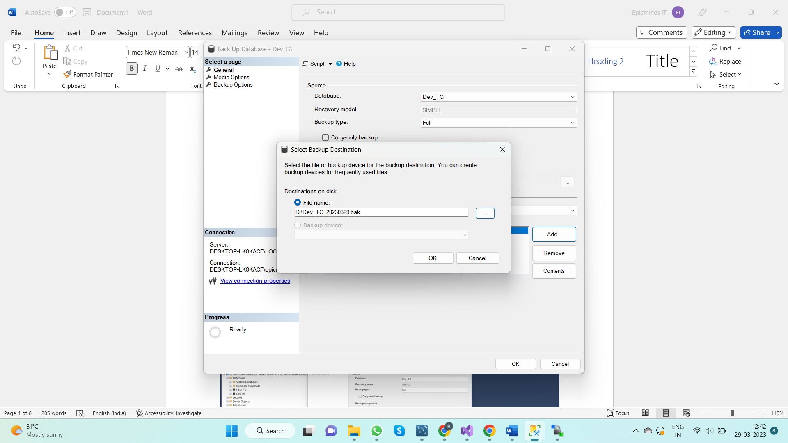

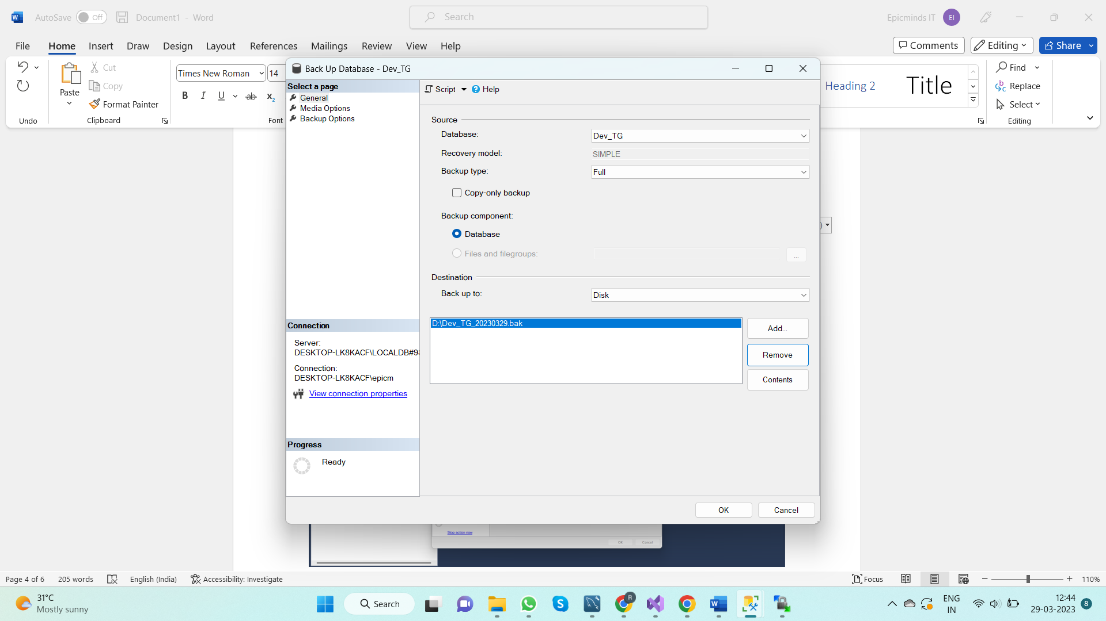

1. You will see the following message.

**(“The bacup of the database ‘Dev_TG” completed successfully”)**

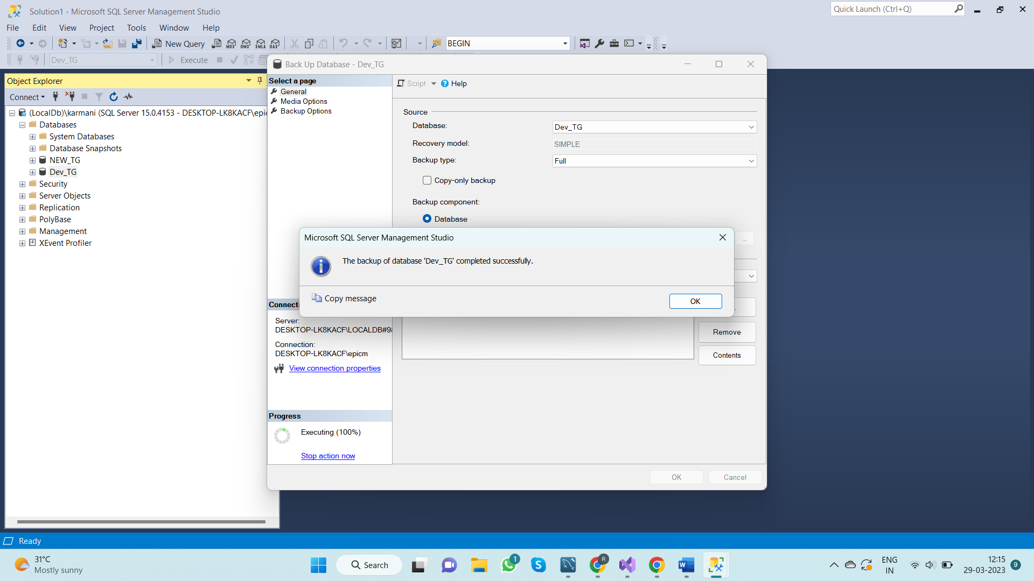

1. Once the backup is completed you can find the backup file in the path which you have selected.

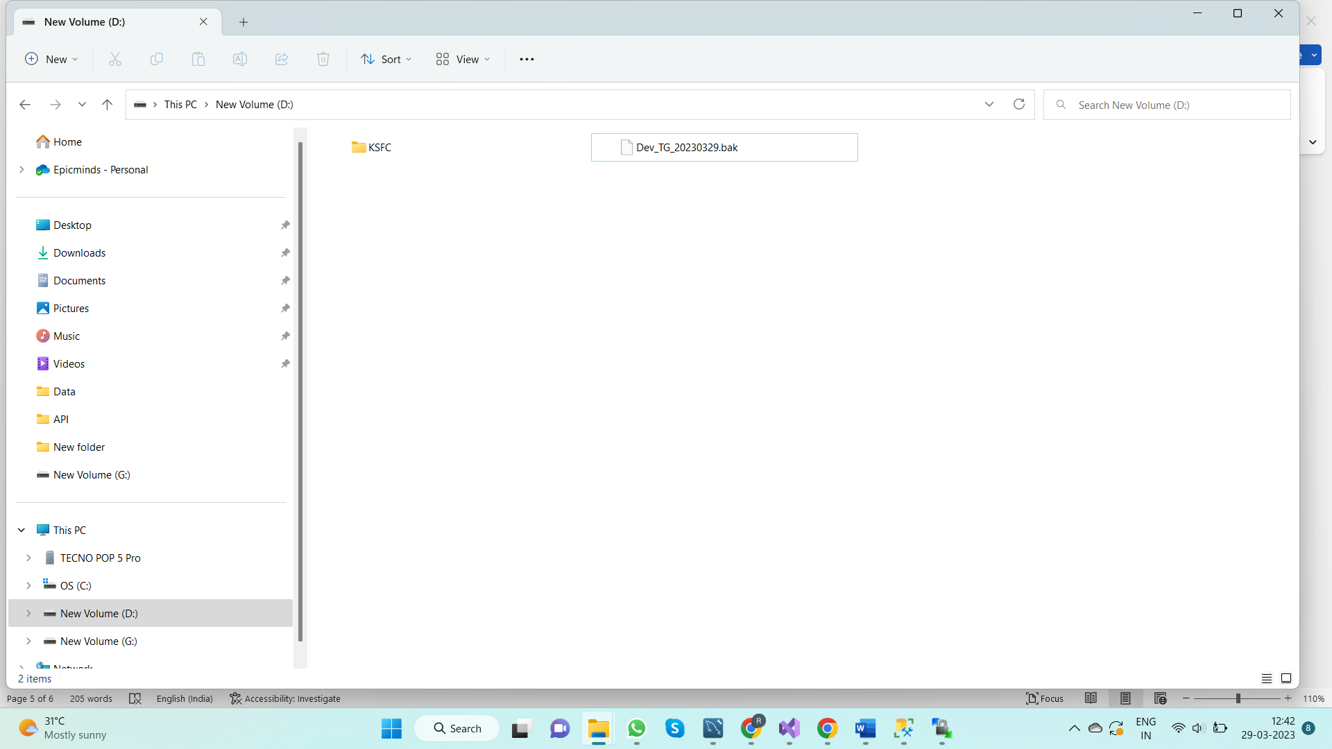

**Step – 2 – Copy the backup file to remote directory**

1. Open “**WinSCP”** and connect to the server **“103.138.197.48”**

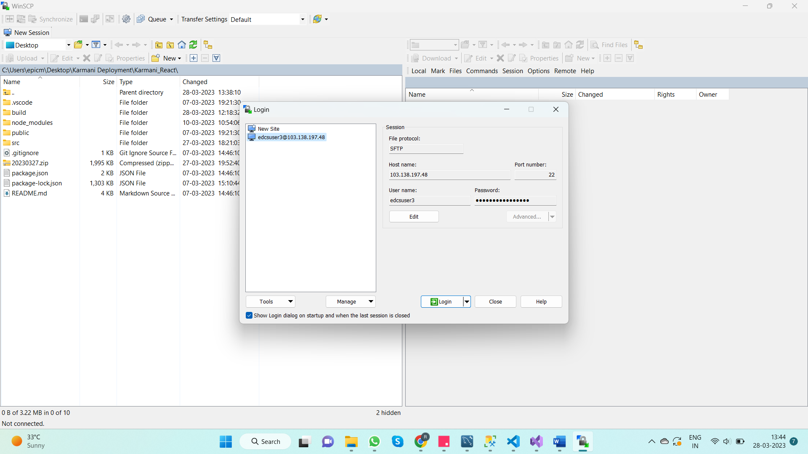

1. Once connected to remote server through “**WinSCP”**, you will see the remote directory tree on the right-hand side of the window, and your local directory tree on the left-hand side.

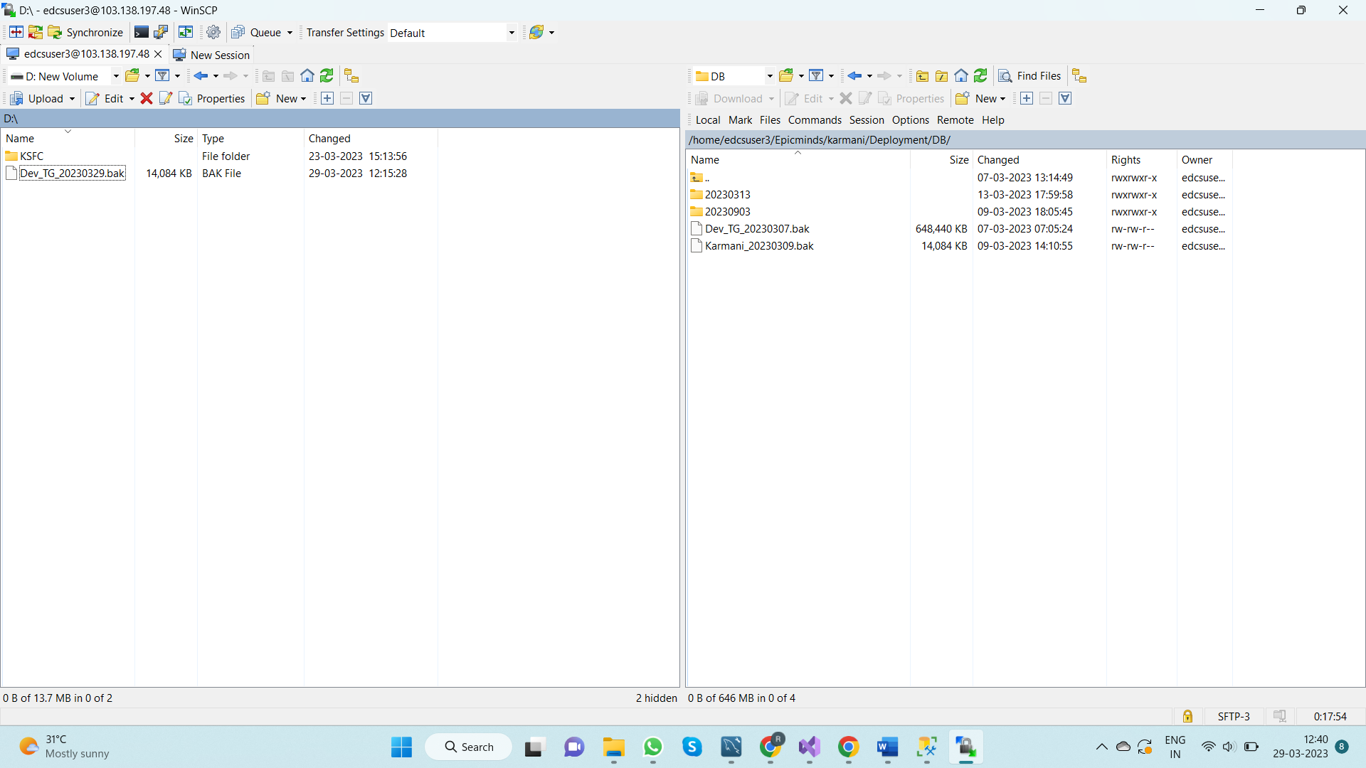

1. Go to the path in which the backup file is located in the local directory and drag and drop it to the path **“/home/edcsuser3/Epicminds/karmani/Deployment/DB”** in remote directory



**Steps to be followed in Server laptop**

**Step-1 -> Copy the backup file from WinScp server to application server**

1. Open RDC (windows+R and type mstsc and enter) in Server Laptop and connect to application server (**10.10.135.171**)

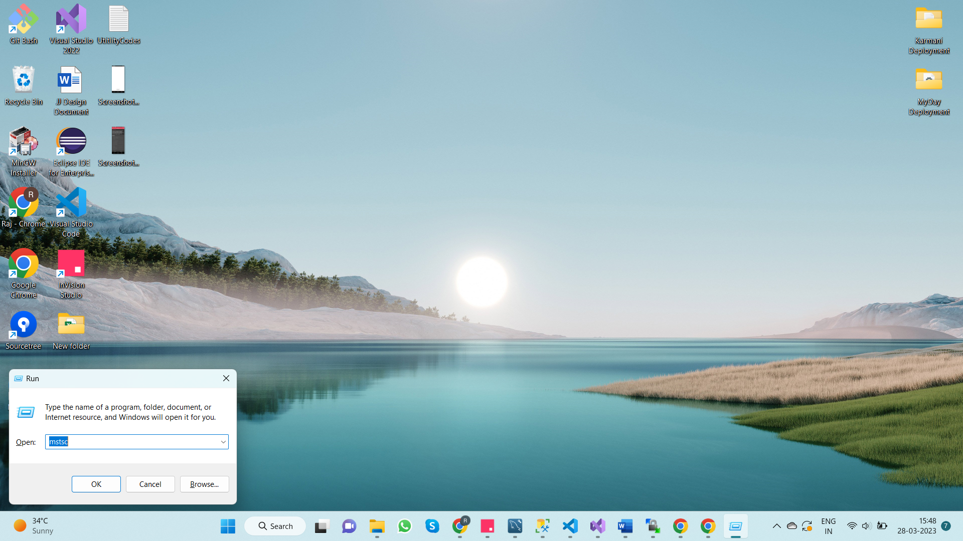

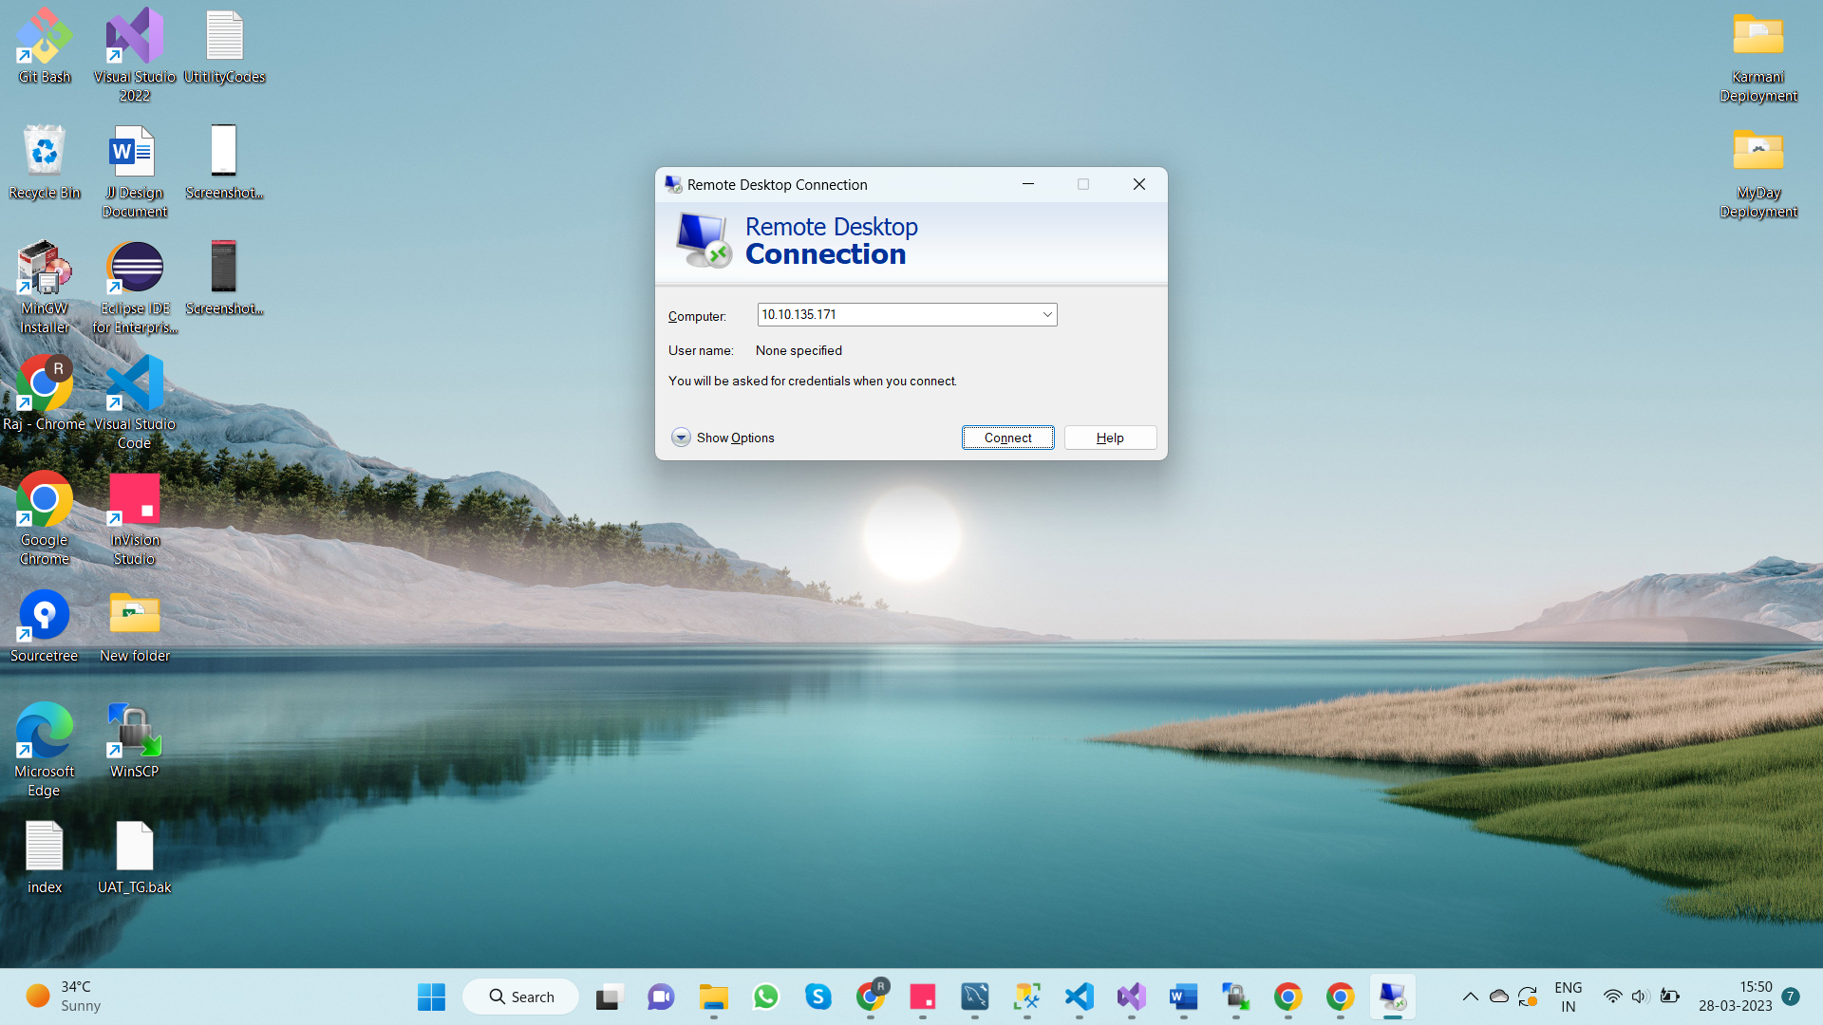

1. Open WinScp in Application server and connect to **“10.10.135.56”**

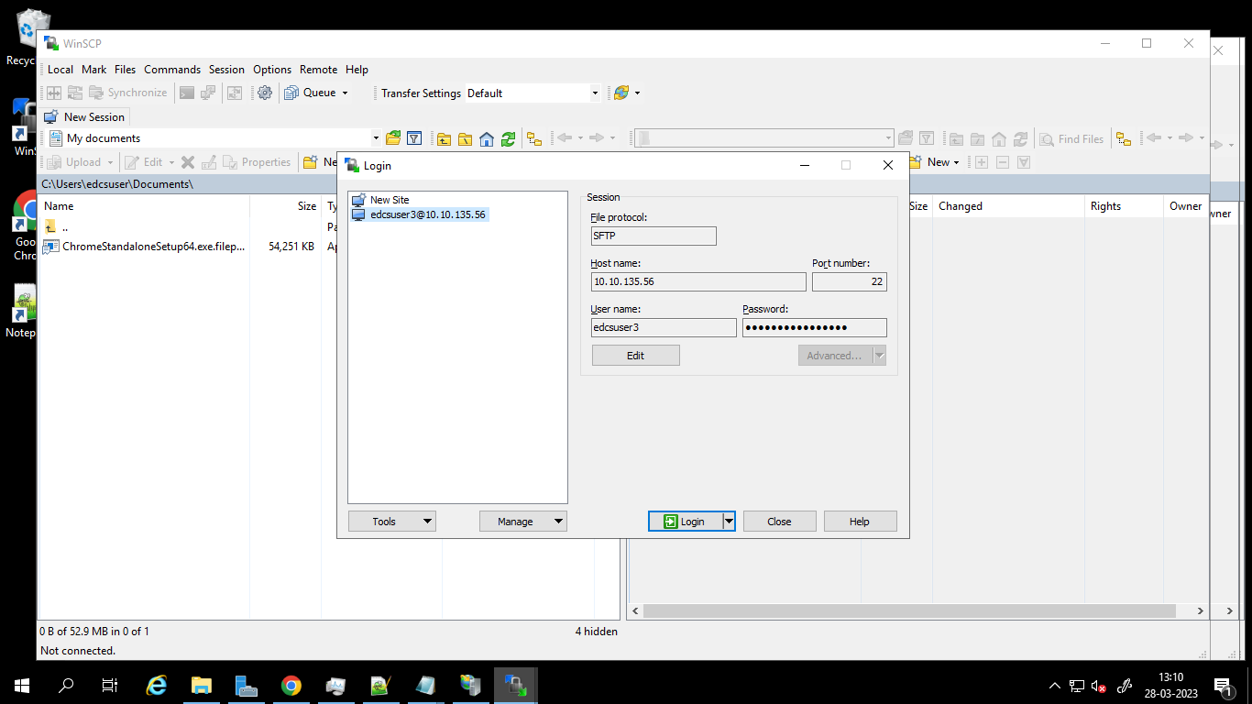

1. Copy the backup file from the path **“/home/edcsuser3/Epicminds/karmani/Deployment/DB”**

To

**“E:\EpicmindIT\DB”**

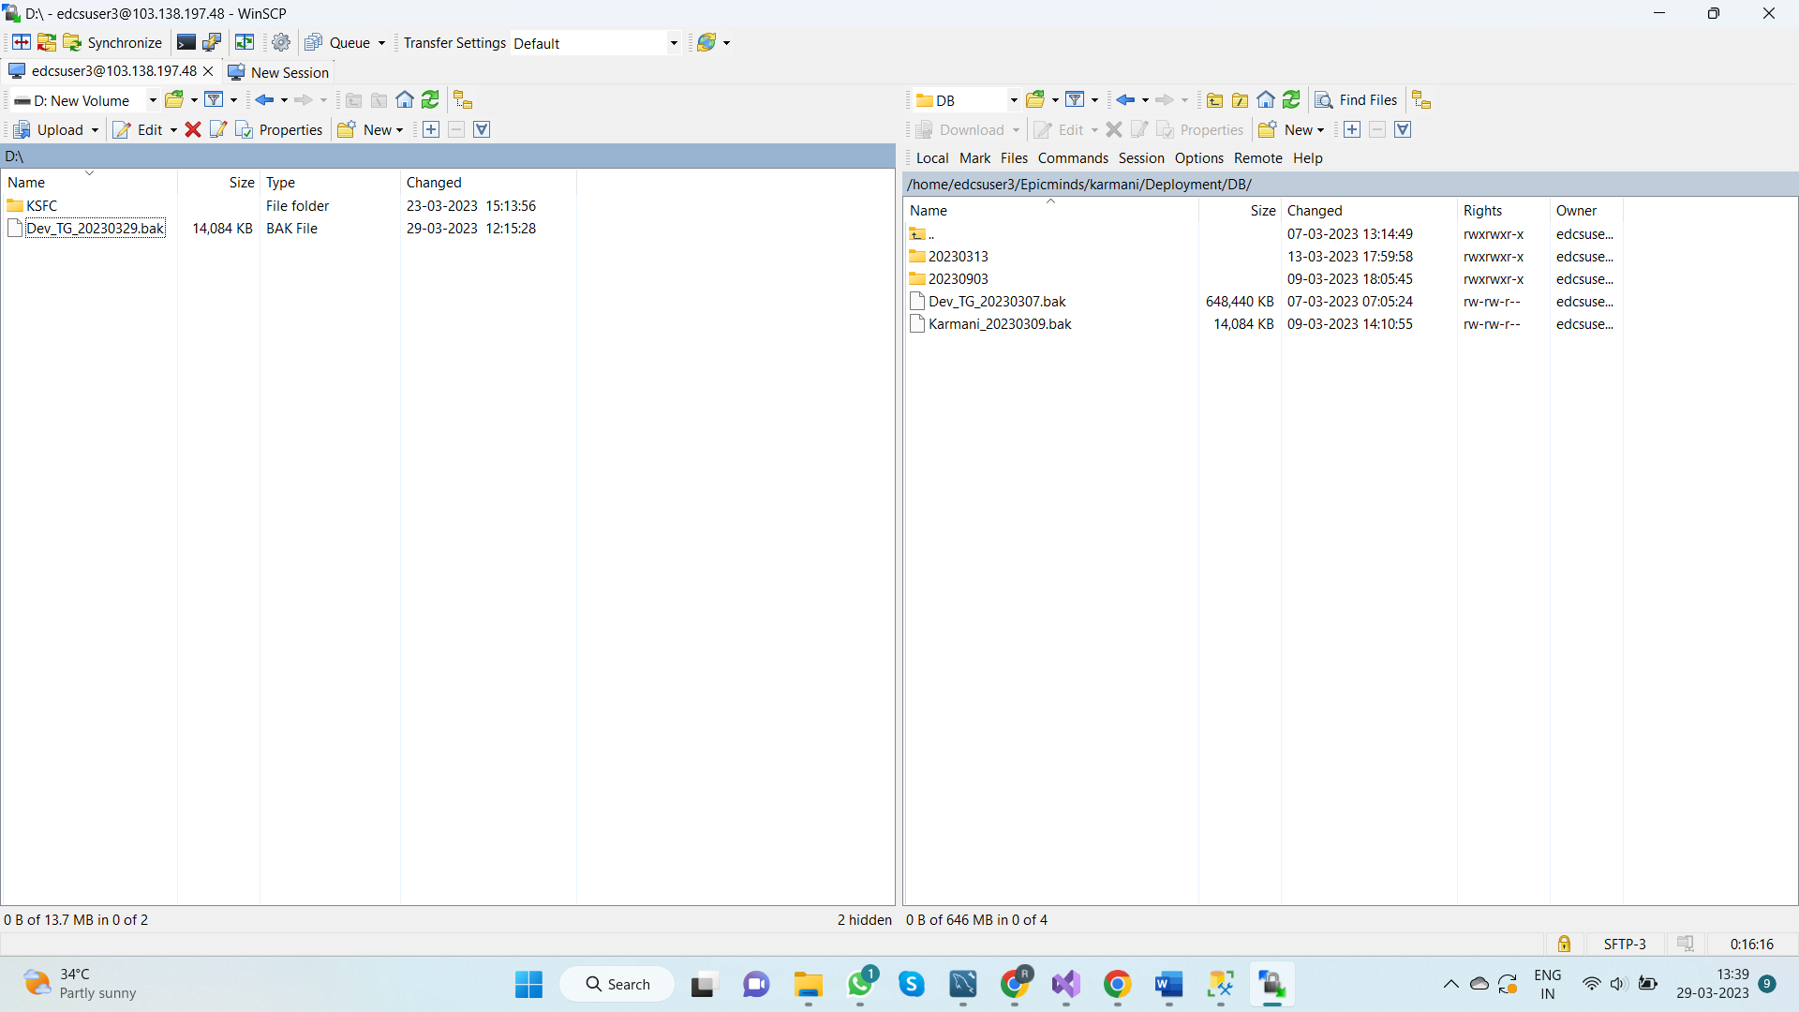

1. Once the above step is completed ask **“KSDC”** team to copy the backup file from **“Application server”** **(10.10.135.171)** to **“DB server” (172.31.61.100)**

**Note: Ask copied location of backup file in DB server to “KSDC” team.**

**Step-2 -> Restore the backup file DB server.**

1. Open RDC (windows+R and type mstsc and enter) in Server Laptop and connect to DB server (**172.31.61.100**)

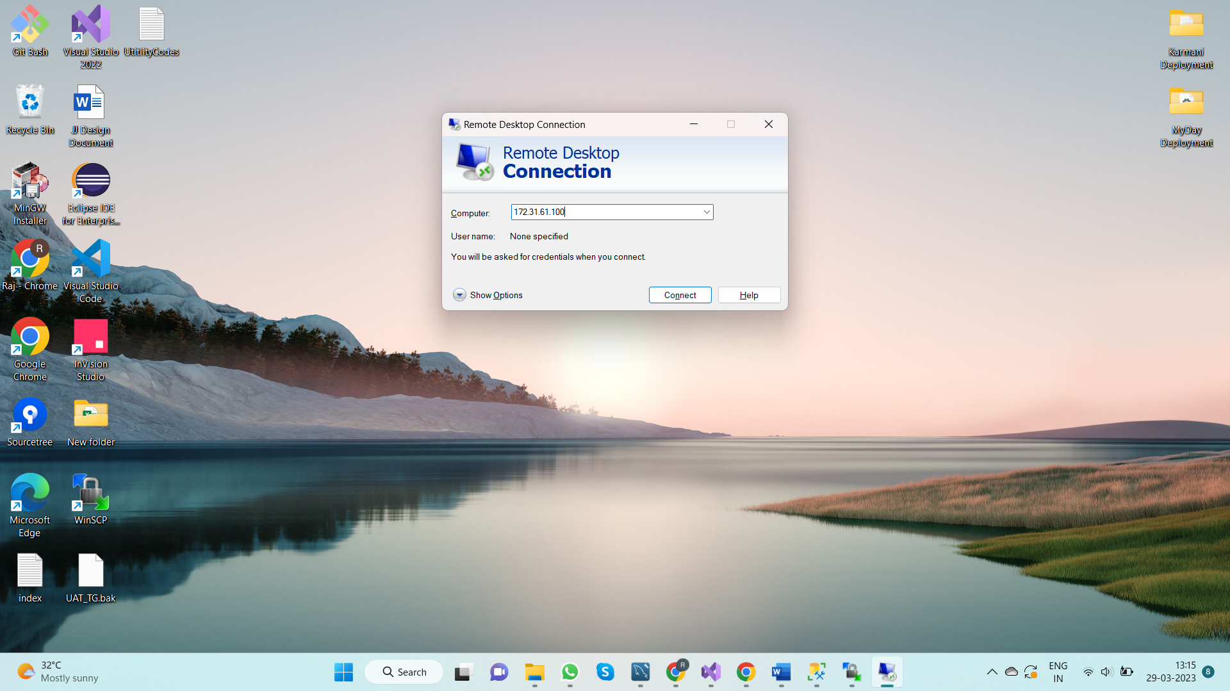

1. Open SSMS in DB and connect to the server **“EDCS-DB-VP15”**

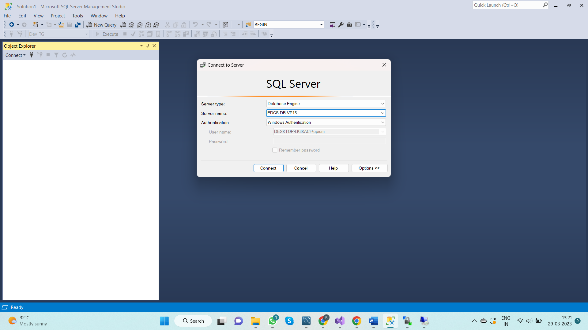

1. Right Click on “**DataBases”** and select “**Restore Database”**

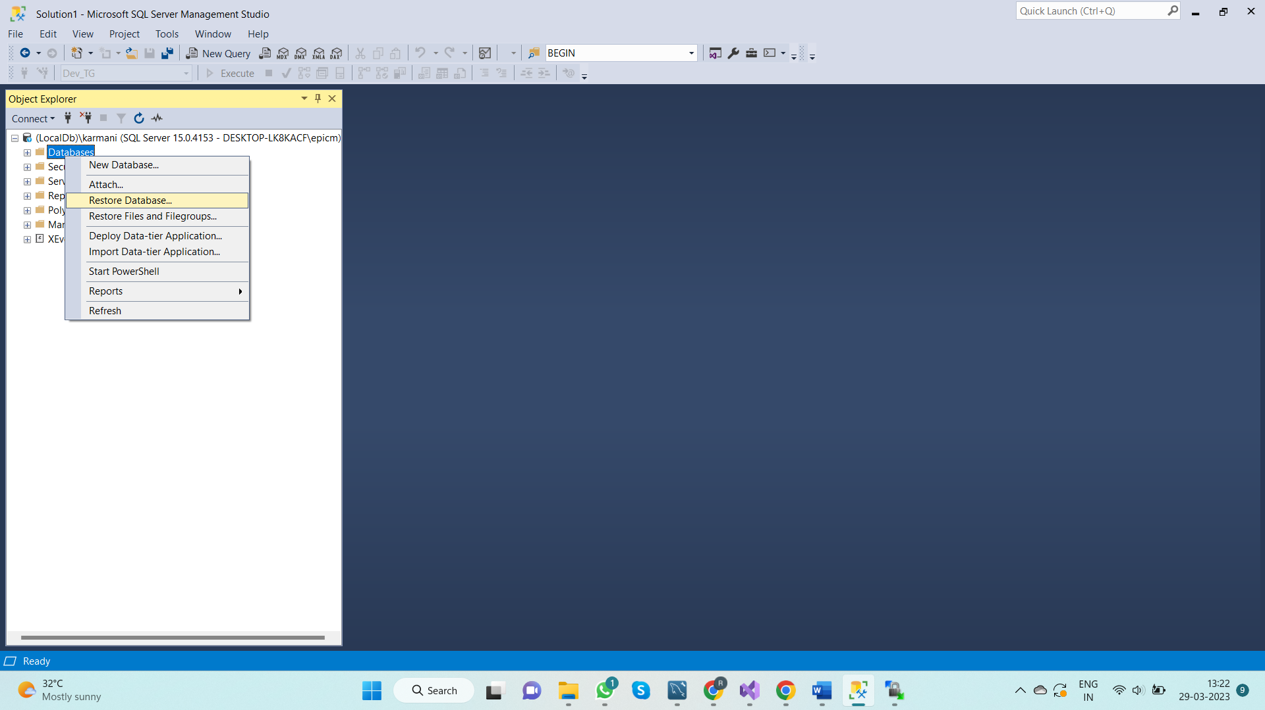

1. Under “**Source”** Select “**Device”**.

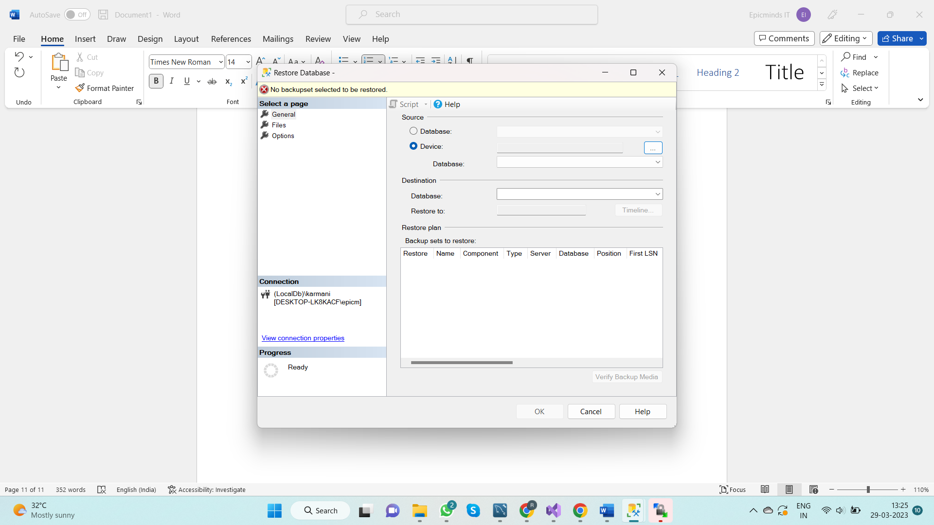

1. Click on Browse. Select **“Backup media type”** as “**File”**

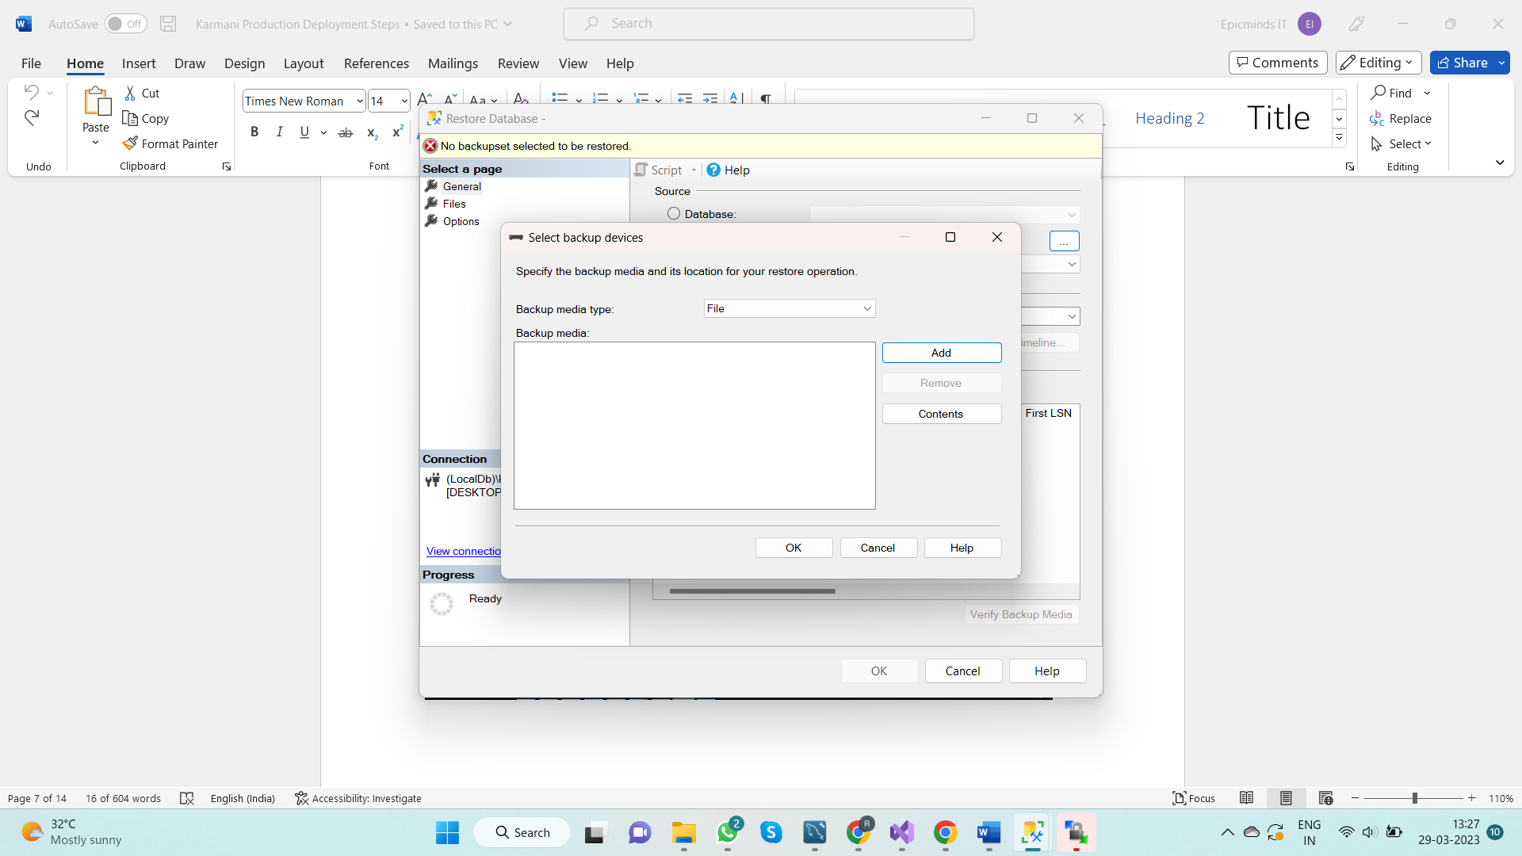

1. Click on “**Add”** and Browse for the path in the back file is located. And Click “**Ok”**.

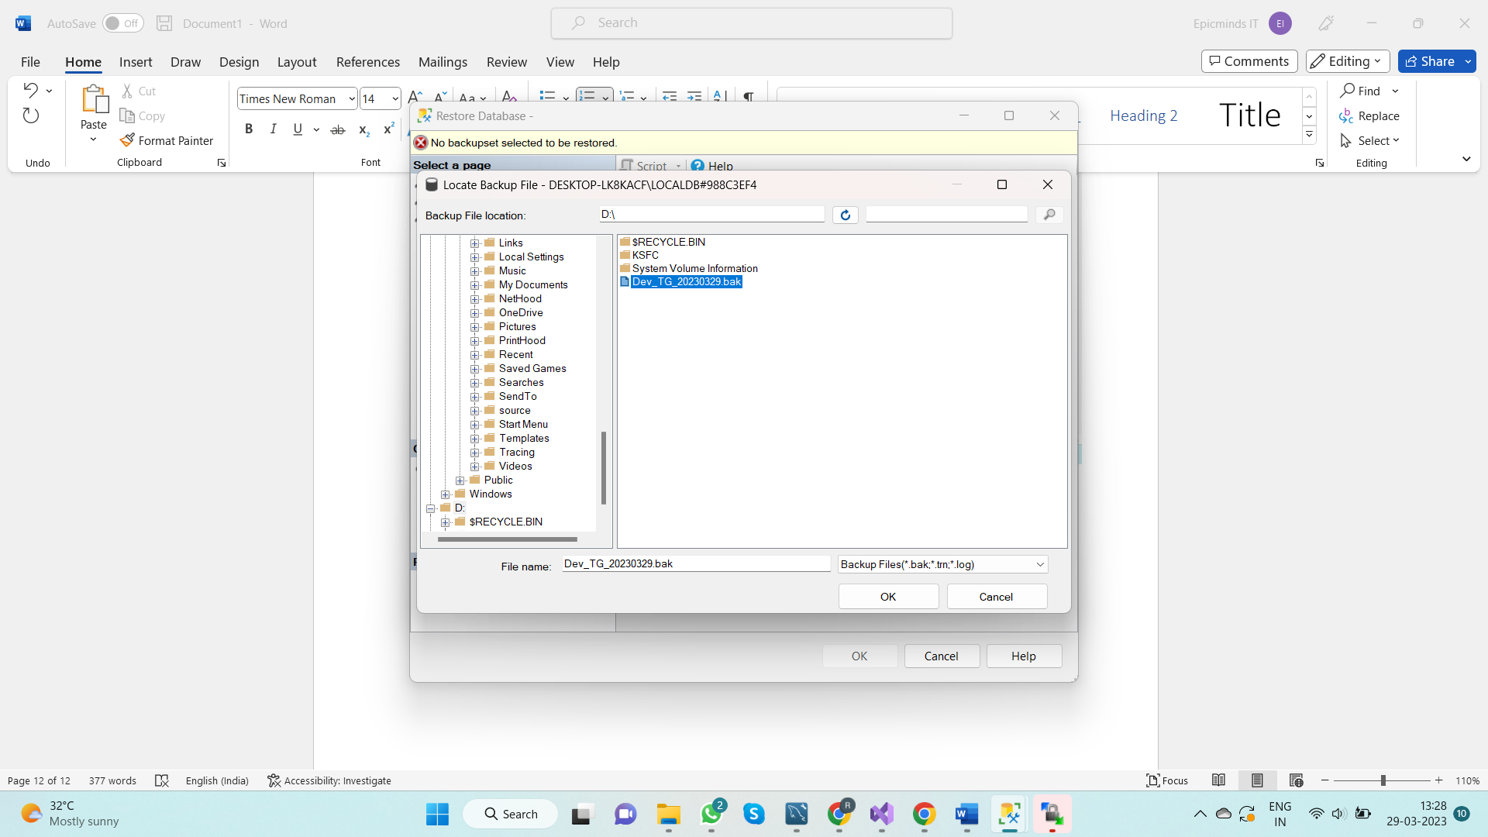

1. Once the below screen appears Click “**Ok”**.

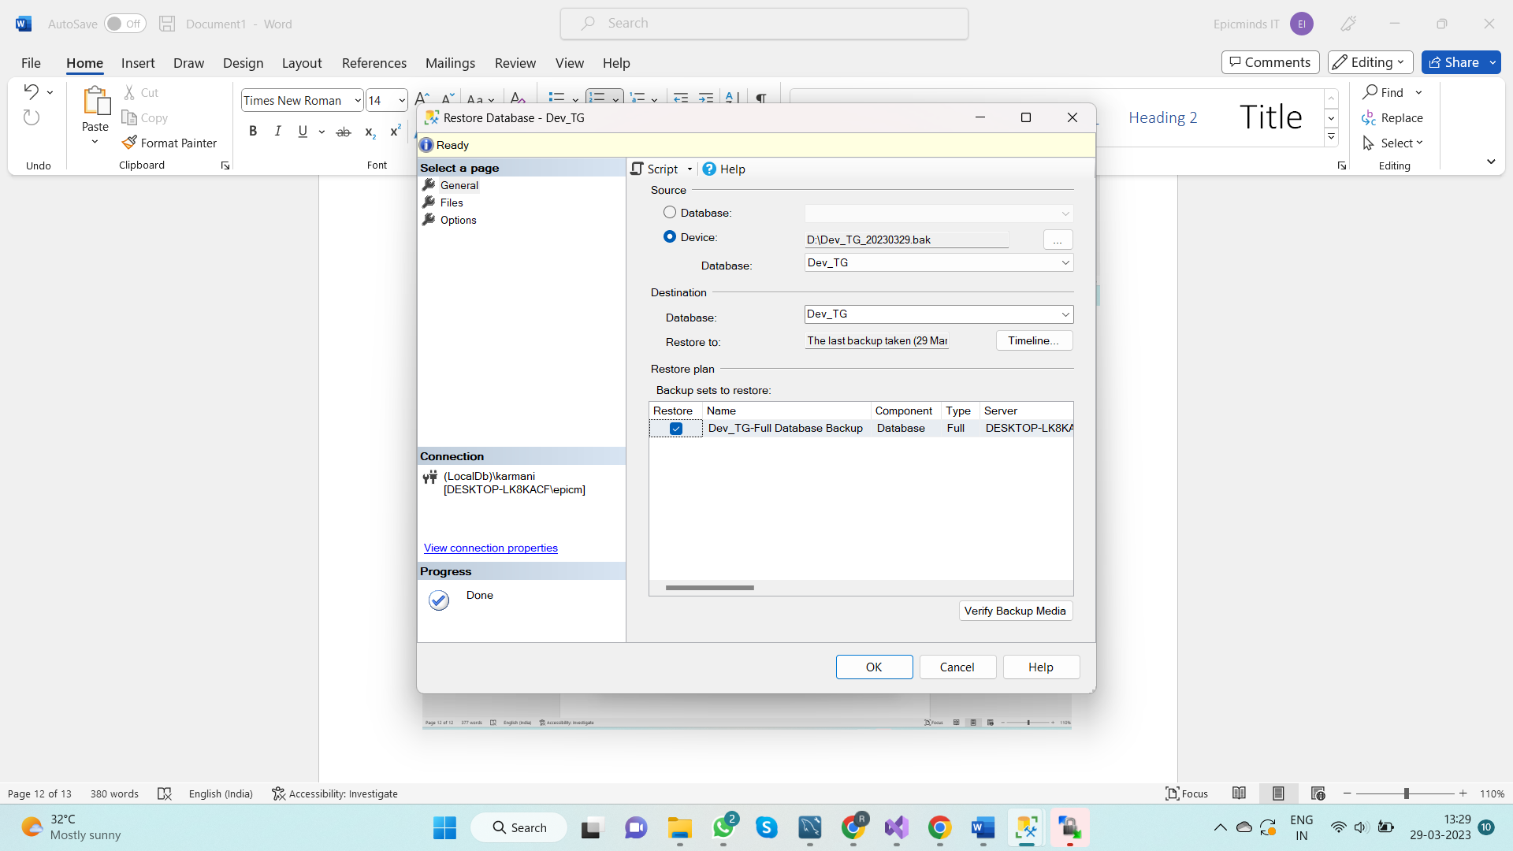

1. You will see the following message. Which indicates the file has been successfully Restored.

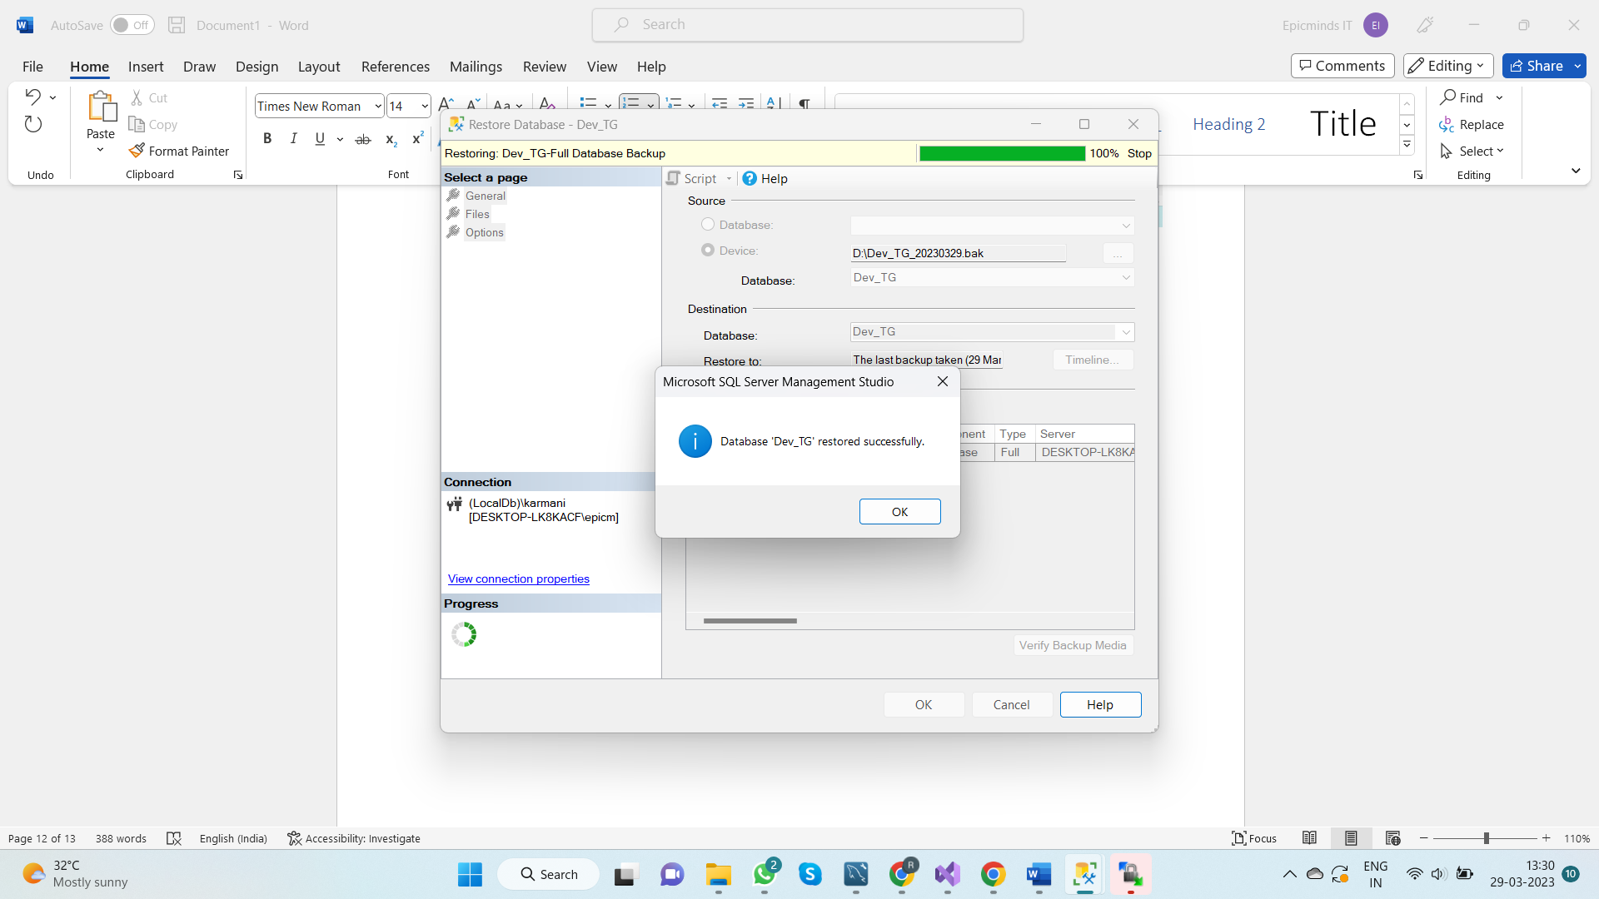

g. Once the backup file has been restored expand the “**Databases”** tab to see the restored database.

